Open Circulation by going to the Staff Menu- Library- Circulation
The following window opens. Type in your username and password.
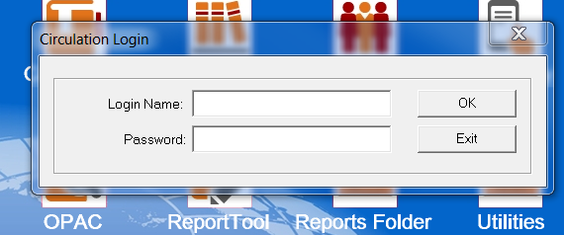
Returning One Item
To return an item:
1. On the toolbar, click Return.
2. In the Barcode box, scan or type the item barcode, and then press ENTER. This returns the item.

